Unit 8: Quadratics

Lesson 5: Using all 4 methods..

Objectives:

* I can solve quadratic equations by taking the square root
* I can change the standard form to vertex form
* I can solve a quadratics by completing the square

Agenda:

* Video
* practice
* Applied problem

Focus Questions:

* How can solve quadratic equations by taking the square root?
* How can we change the standard form of a quadratic to the vertex form?
* How can I solve a quadratic by completing the square?

Vocabulary:

Perfect Square, standard form, Vertex form, completing the square

Homework: HW 8-5

Web Support:

<https://www.youtube.com/watch?v=8kvb6YVHtYc>

**Do Now**

1. Find the x –intercepts of this quadratic equation by factoring, graphically and by using the quadratic formula. $x^{2}+5x-24=0$

|  |  |
| --- | --- |
| **Graphically: List the steps:** | **Factoring ( 0 product property)**  **Meaning you must factor first:** |
|  |  |
| **Quadratic formula:** | **Solce by completing the squre and state the values of the vertex.**  See the source image |

**Mixed PRACTICE:**

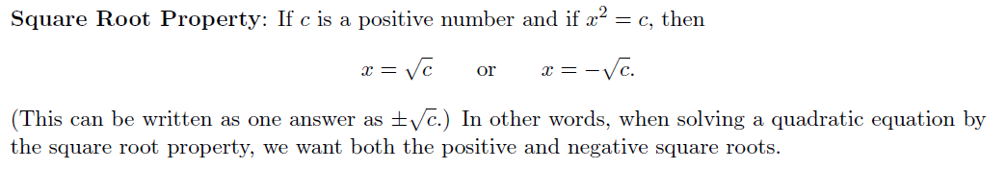

2. 3.

**Solve the following quadratics by completing the square:**

4. 5.

**Solve the following quadratics by using the quadratic formula:**

6. 7.

**Solve the following quadratics by using the 0 product property:**

8 $x^{2}-4x-60=0$

**Name: ______________ Date: __________: Homework 8-5**

Solve the following quadratics by **taking the square root:**

1. 2.

4.

**Solve using the quadratic formula:** 

**5. ${ x}^{2}+12x+27=0$**  6. $x^{2}+4x-10=2$

7.A player kicks a soccer ball with upward. The quadratic function $h = -2t^{2}+ 16t +2$ represents the height of the ball h in feet after t seconds.

1. Make a sketch of the graph using an appropriate window.
2. What is the maximum height?